Install laravel in xampp

1 – First download xampp from site
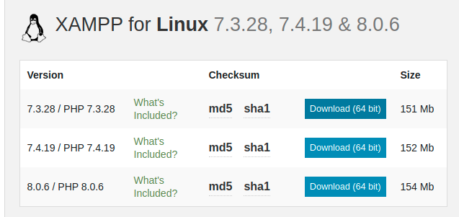

2 – go to download folder search for the downloaded xampp file and install
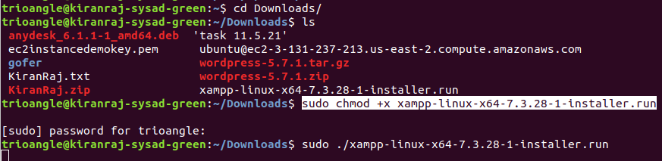

3 – after run that cmd xampp pop up box open
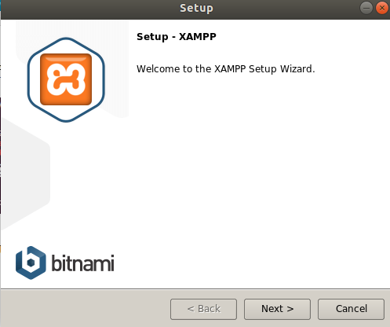

4 – once finish it set up the executable path , for that we need to add php path in our system path
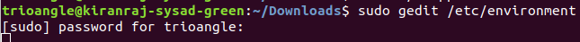

the gedit path will open
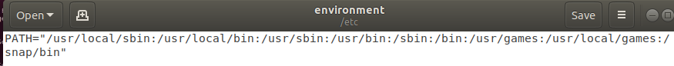

5 – in this path add the following path at the end
:/opt/lampp/bin/php

This is the file that lampp install for the php in our system
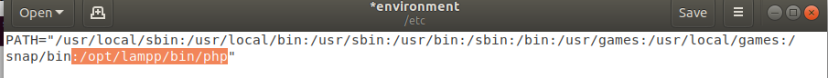

once save and close the file terminal shows like this
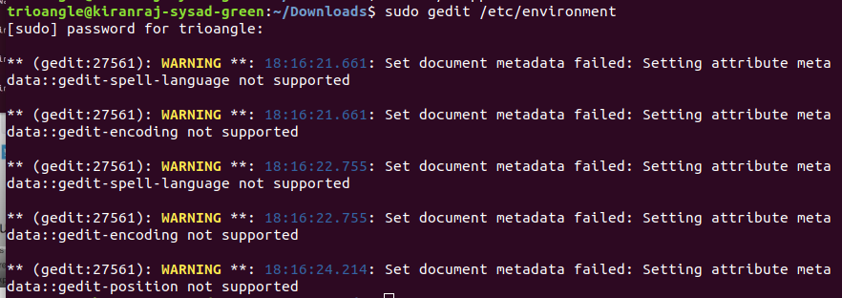

6 – now we need to create a symbolic link fo this php executable by providing the following command
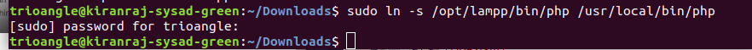

7 – now we need to start xampp service by providing following command

sudo /opt/lampp/lampp start
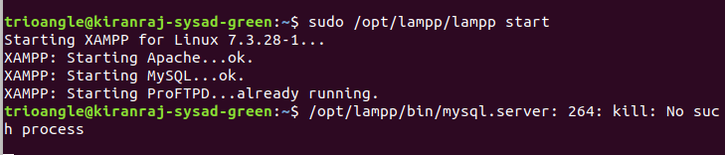

If apache2 starts to fail stop the apache2 in local

8 – now install composer using the following cmd
curl http://getcomposer.org/installer | php
if error occurs try to install curl fist by giving sudo apt-get install curl
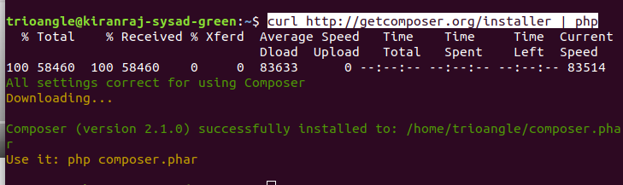

9 - now we need to move this composer file to our linked php location
sudo mv composer.phar /usr/local/bin/composer
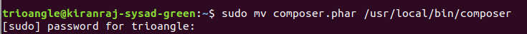

10 – now create a new laravel project by giving the following cmd
composer create-project --prefer-dist laravel/laravel myapp
laravel start to download
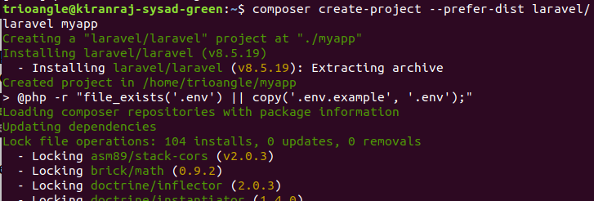

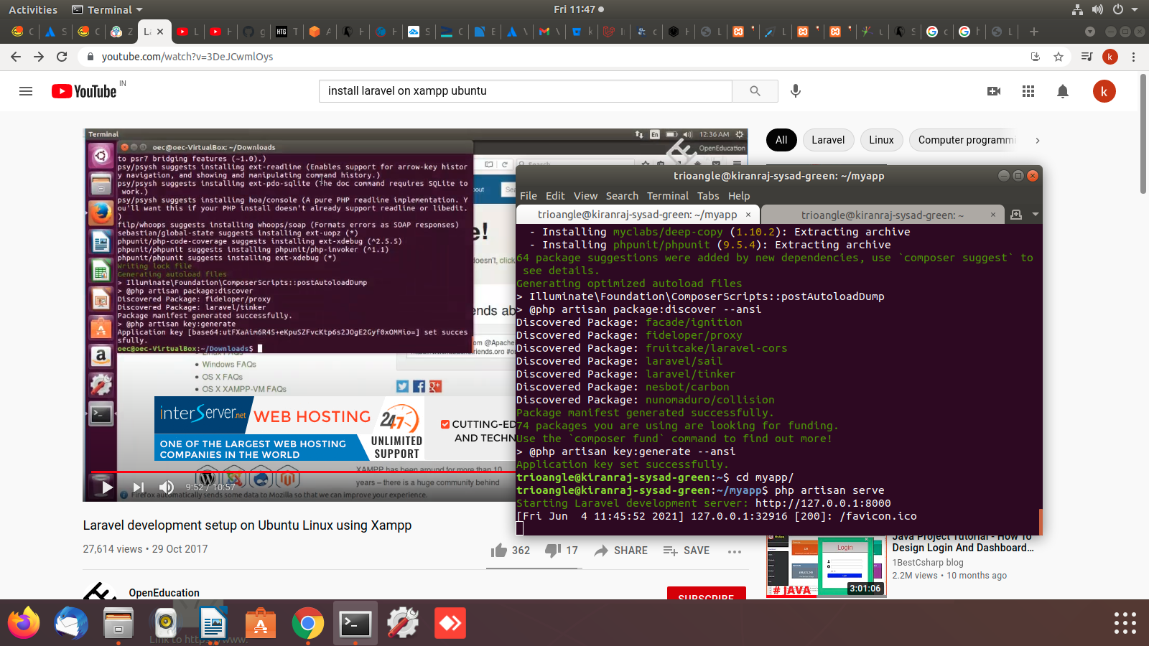

11 – once download complete to the myapp folder which we created and enter the following cmd to run the
laravel project
php artisan serve

12 – now go to your browser and type localhost:8000 to check the laravel page is loading
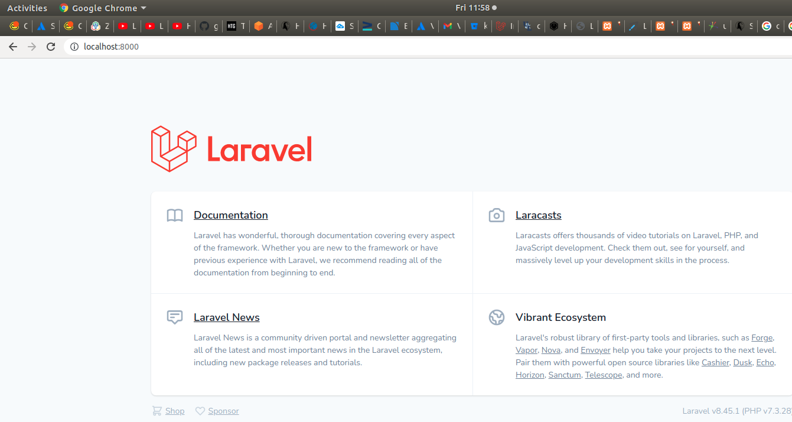

https://www.techiediaries.com/install-laravel-8-php-7-3-composer/

now laravel installed using xampp

